Pupil Version
Making the most of Google Classroom
For each class, you share a Classroom calendar and a Google Calendar with your teacher and classmates.
It would be sensible to start your day by looking at your calendar, then completing the work in the order that it is due. You can do this by clicking on the assignment on your calendar; this will take you straight to the instructions / resources for this piece of work.

What can you do with calendar?
Note: Classroom calendar is available only on computers, not mobile devices. See the end of these instructions how to access a Classroom Calendar on a mobile device.
Google Calendar | Classroom calendar
- View classwork due dates  - View class events  - Add personal reminders  only you see  - Add events, such as  study sessions | - View classwork due dates  - Click an item to open it  in Classroom

View due dates on your Classroom calendar
On the Classroom calendar, you can see classwork due dates. You can't add any items.
- Go to classroom.google.com.
- At the top, click Menu .
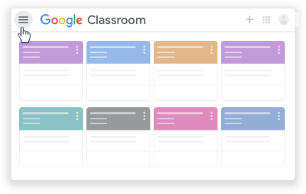

- Click Calendar.
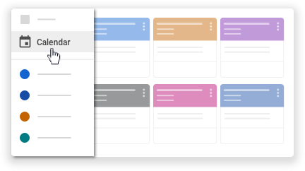
It will look something like this:
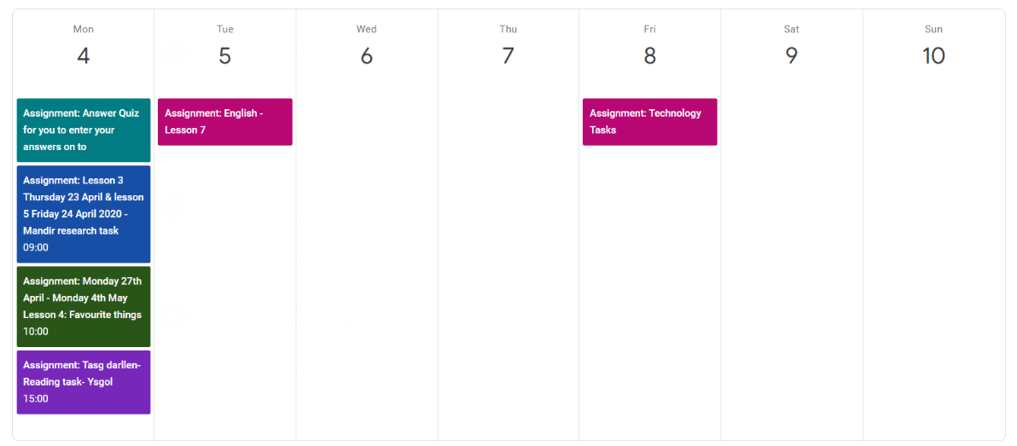
- Choose an option:
  - To see past or future work, next to the date, click Back or Next .
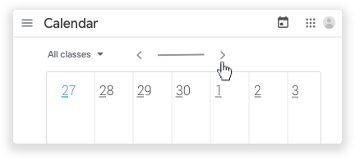
  - To see assignments for all your classes, click All classes.
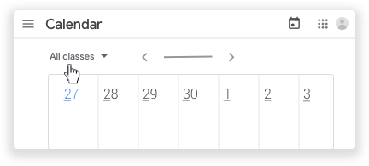
  - To see assignments for one class, click All classes select the class.

- Your calendar is interactive; to open classwork, click an assignment or question.
TIP: Print out your calendar weekly, stick it on your wall and cross off the work as you complete it!
Using a Mobile Device
Please note - you can't see automatically see your calendar on the Google Classroom App on phones or Ipads. However, if you download the Google Calendar app onto your phone and Ipad then you can sync it to your account by following these instructions. This will then show your assignments on your phone:

Download Google Calendar
Open Google Calendar
It will ask you if you wish to link the calendar to your Google account.
Slide to indicate yes.
If your assignments are not showing on the calendar straight away, you should:

Click the three lines on the LHS
Click SHOW MORE underneath REMINDERS
You can then tick the subjects that you want to show up on your calendar.

Tip: Only link the classrooms currently being used.

For more support with Google classroom visit this link:
https://support.google.com/edu/classroom#topic=6020277

