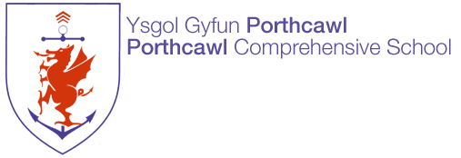

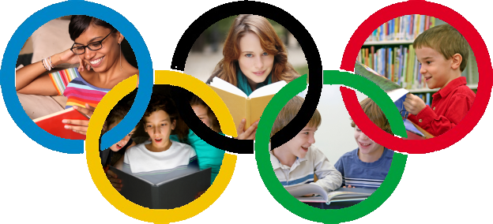

Year 6 Summer Reading Challenge
2019

A guide for parents & students

The Value of Reading

At Porthcawl Comprehensive School, we want to encourage students to read as often and as widely as possible. Research tells us that children who are very good and confident readers by the age of 15 are most likely to go on to achieve well at school, college and university and throughout their careers and lives. We also know that students who read for just half an hour a day can be up to a year ahead of those who don’t by the time they turn 15. Reading is a vital skill!

To encourage students to read more often, we are launching our Summer Reading Challenge. We want to encourage every student to read more often, to read more widely, and to find something they love reading. We also want to encourage parents to engage with the Challenge, both by helping their child to find and read good books, and by reading themselves.

So take up the challenge – and become a reader!

Porthcawl Comprehensive School
English Department

The Reading Challenge

To encourage frequent reading, we are setting some challenges to Year 6 into 7 students, with Bronze, Silver and Gold Awards for those who do well. The challenges are set out here, and also in the Reading Challenge card that all students have been given:

2 Point Challenges
02
- Read a book someone else has recommended
- Recommend a book that someone else then reads
- Discuss a book with someone else who has read it
- Read a book to someone else (e.g. brother or sister)
- Write a book review for display

3 Point Challenges
03
- Learn a favourite poem by heart
- Read a sequel to a book you’ve already read
- Read a book from the Key Authors list on page 6
- Read a book and watch the film that goes with it

5 Point Challenges
05
- Read a book from the Top 20 booklist on pages
4 & 5
- Read your parent’s favourite childhood book
10
10 Point Challenge
- Read a book from the Classics list on page 6
- Write a 150 word book review
- Create a Body Biography for the main character
- Write a summary of your book

Top 20 Reads

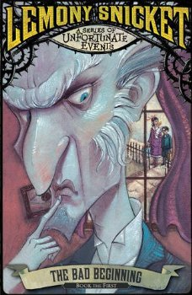 | A Series of Unfortunate Events  By Lemony Snicket  Artemis Fowl  By Eoin Colfer | 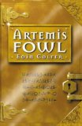
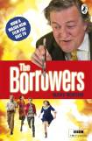 | The Borrowers  By Mary Norton  The Boy in the Striped Pyjamas  By John Boyne | 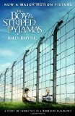
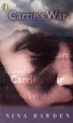 | Carrie’s War  By Nina Bawden  Charlotte’s Web  By E. B. White | 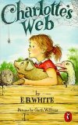
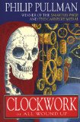 | Clockwork  By Philip Pullman  Cosmic  By Frank Cottrell Boyce | 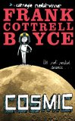
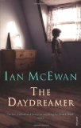 | The Daydreamer  By Ian McEwan  Diary of a Wimpy Kidd  By Jeff Kinnell | 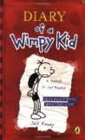
Recommendations

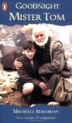 | Goodnight Mister Tom  By Michelle Magorian  My Swordhand is Singing  Marcus Sedgewick | 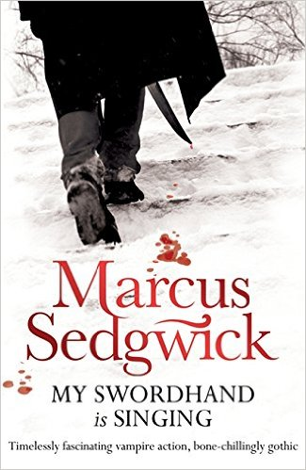
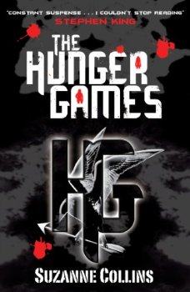 | The Hunger Games  By Suzanne Collins  The Lion, the Witch & the Wardrobe  By C. S. Lewis | 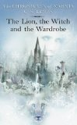
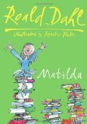 | Matilda  By Roald Dahl  Private Peaceful  By Michael Morpurgo | 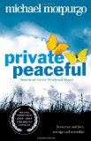
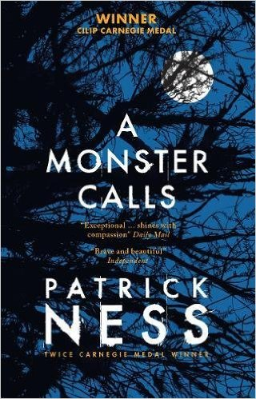 | A Monster Calls  By Patrick Ness  Holes  By Louis Sachar | 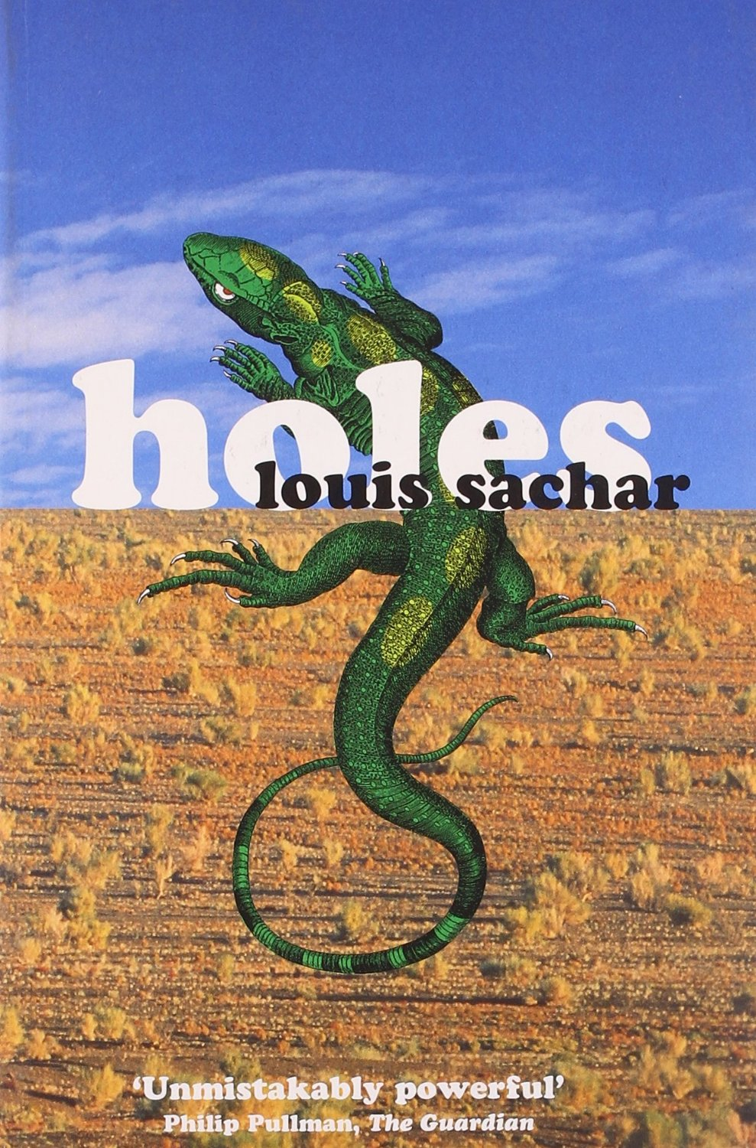
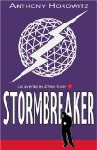 | Stormbreaker  By Anthony Horowitz  There’s a Boy in the Girls’ Bathroom  By Louis Sachar | 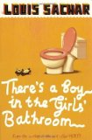
Classics
Why not try something different and go for one of these older ‘classic’ texts? Or one of the recommended authors below?
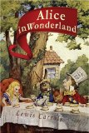 | Alice’s Adventures in Wonderland  By Lewis Caroll  A Christmas Carol  By Charles Dickens | 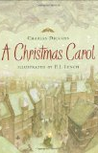
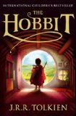 | The Hobbit  By J. R. R. Tokien  I Capture the Castle  By Dodie Smith | 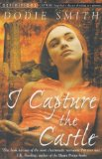
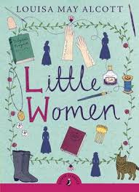 | Little Women  By Louisa May Alcott  The Lion,  the Witch and  The Wardobe  By C.S. Lewis | 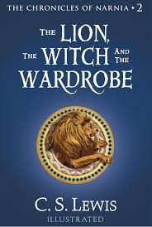
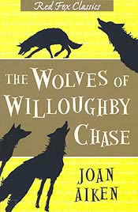 | The Wolves of  Willoughby Chase  By Joan Aiken  Treasure Island  By Robert Louis Stevenson | 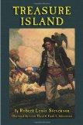
Authors

Malorie Blackman
Judy Blume
Roald Dahl
Anne Fine
Nigel Hinton
Anthony Horowitz
Michael Morpurgo
Robert Swindells
Robert Westall
Jacqueline Wilson
Charlie Higson
JK Rowling

What else can we do?

There are lots of things that families can do together to support the improvement of reading ability and enjoyment.

Talk as a family about reading
By Year 7 most students are competent readers and are less likely to read aloud to an adult. That’s a natural progression, but it doesn’t mean that parents don’t have a part to play. The higher level skills of inference and understanding the craft of an author can be supported by talking about what has been read.

Share a book
Just because you don’t necessarily read together doesn’t mean that parents and children can’t share a book. Young Adult fiction is excellent and well worth a read as a parent. Why not both read the same book?

Model what it is to be a reader
Many parents will read, whether it be fiction, newspapers, online or in any other context. Get in the habit of being seen to read, and valuing reading.

Join the library – and visit!
Library membership is free, and the library is just a short walk from school.

Download books on an iPad, Kindle or phone
It doesn’t have to be paper – download your book so you have it to hand to read whenever you have a few spare minutes! You can change the font size, look up tricky words and know how many minutes it will take you to finish a chapter! Perfect for reading on the go!

Good Reading

Fiction books aren’t the only sort of reading material that will help you improve your reading ability.

Reading these will help:
 |  | 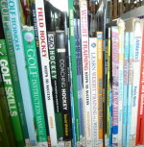
Newspapers | Websites | Non-fiction
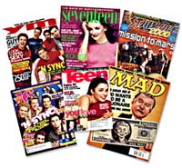 | 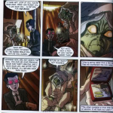
Magazines | Graphic Novels | Audio books

We hope this guide has inspired you and your family to take up the reading challenge !

‘If you don’t like to read, you haven’t found the right book’
JK Rowling

